**JEAP – APPLICANT (BANK SIGNATURE VERIFICATION LETTER)**

**(Format to be verified by Bank Manager of Applicants account)**

This is to certify that Mr./Mrs. ________________________________________________________ with the address (Bank Address)_____________________________________________________ _______________________________________________________________________________________________________________________________________________________________________

Is maintaining a bank account (A/c No. _______________________________________________)

With our Bank ____________________________________________and operating that account in the normal course. Mr./Mrs. _______________________________________________________ is the authorized signatory for the operation of the account. His signature as appearing below is duly attested (as per the records available with the Bank).

(Signature of the Authorized Signatory) (Signature of the Branch Manager)

Name : __________________________________ Name : ________________________

Date : ____________________ Bank Seal :

---------------------------------------------------TEAR HERE ----------------------------------------

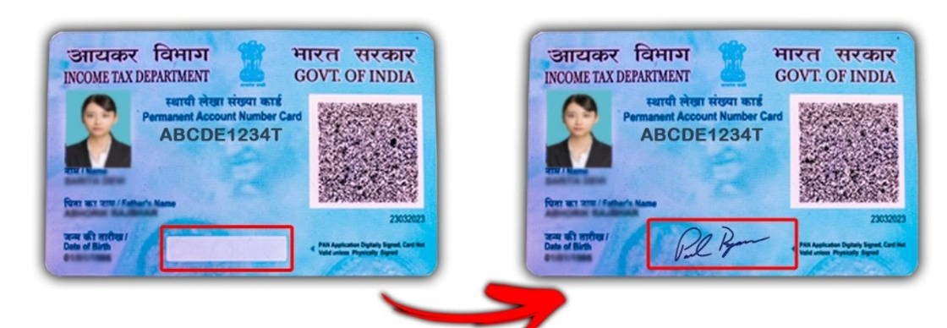

Right Pan Card Accepted, No need for Bank signature verification

Left Pan Card Not Accepted, Bank signature verification required.